1.所有种类的獒犬
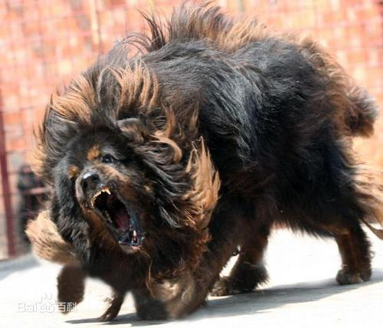

2.比特斗牛梗犬Pit Bull Terrier
3.斯塔福梗犬Staffordshire Terrier

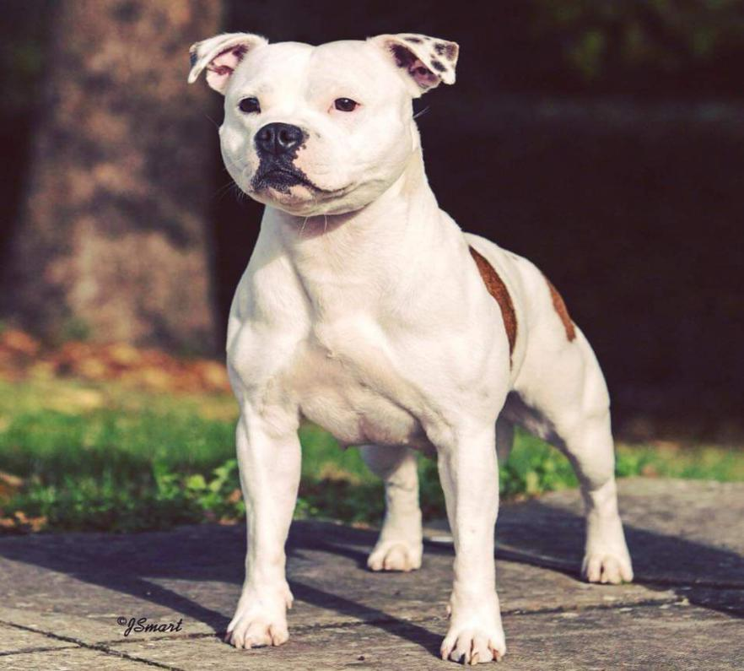
4.阿根廷杜高犬 Dogo Argentina
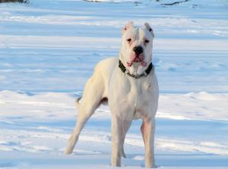

5.巴西非拉狗犬FIIa Braziliero

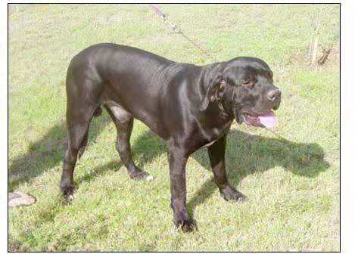

6.日本土佐犬Japanese Tosa
7.意大利卡斯罗犬Cane Corso
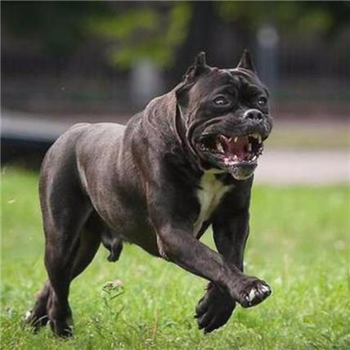
8.中亚牧羊犬Central Asian Shepherd Dog
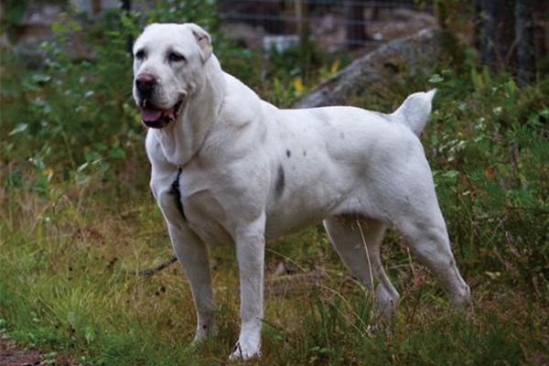

- 俄罗斯高加索犬Caucasian Owtcharka

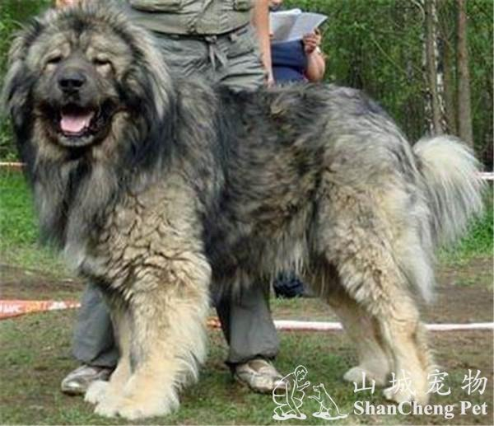
10.罗威纳犬Rottweiler
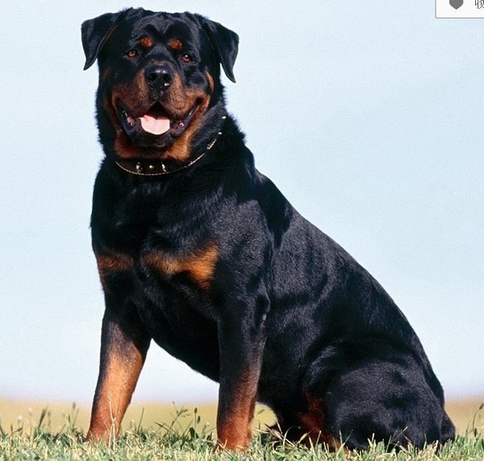
11.杜宾犬(大型)Dobermann
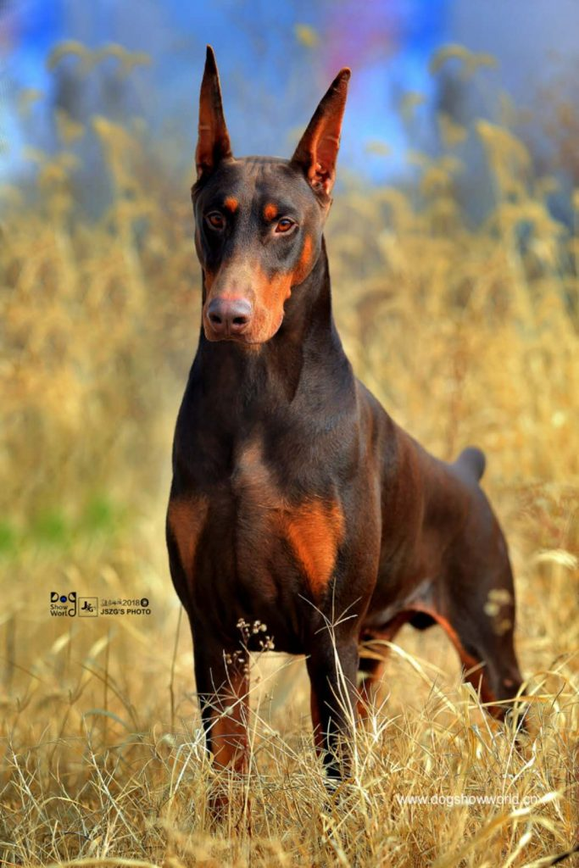
- 英国马士提夫犬Mastiff
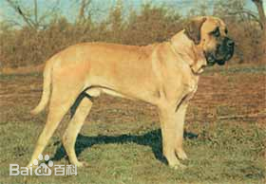

13.比利时马林诺斯犬Belgian Malinois
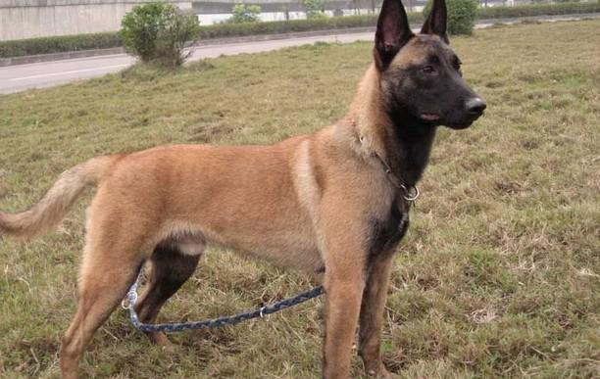

14.苏俄猎狼犬Borzoi
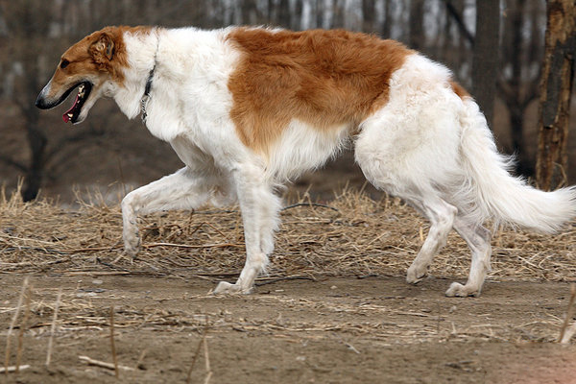

15.圣伯纳犬saint Bernard Dog

16.德国拳师犬German Boxer

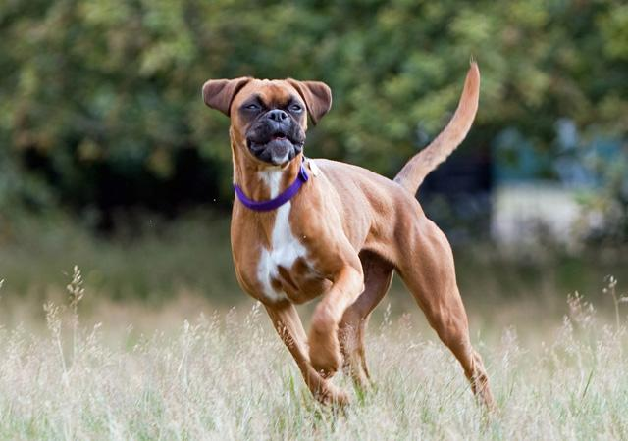

17.秋田犬Akita
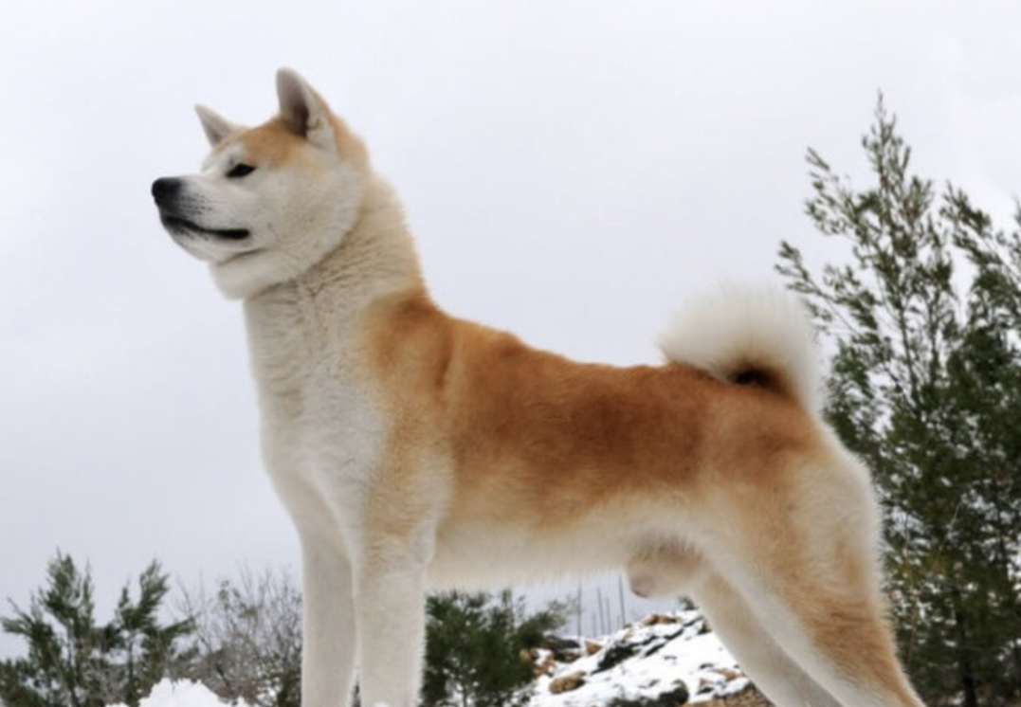

18.比利时牧羊犬Belgian Shepherd Dog
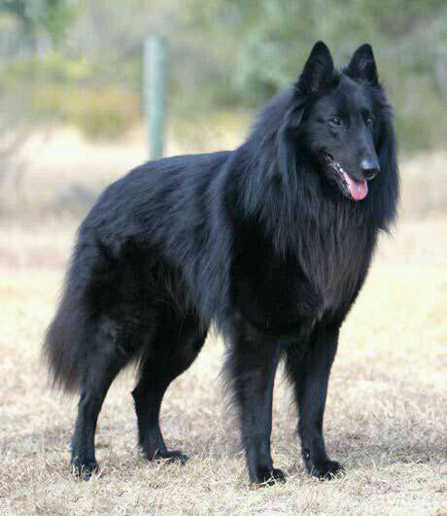
19.荷兰牧羊犬Dutch Shepherd Dog
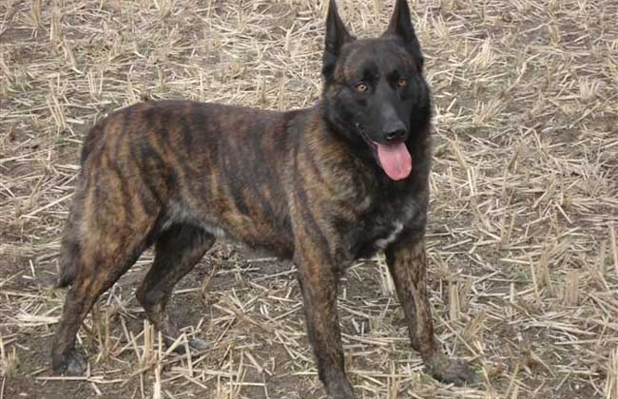

20.德国牧羊犬German Shepherd Dog

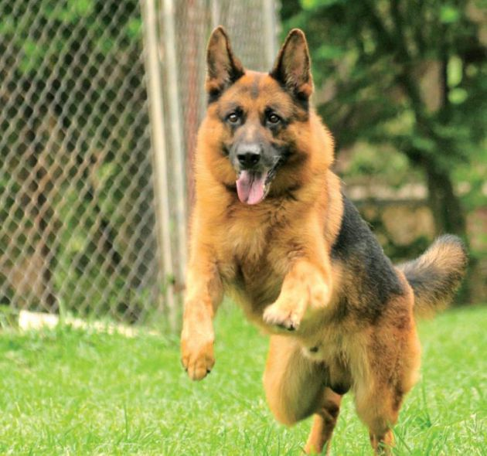

21.法国狼犬Beauceron Wolfdog

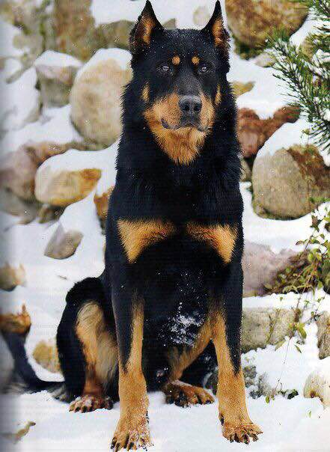
22.捷克猎狼犬Saarloos Wolfdog

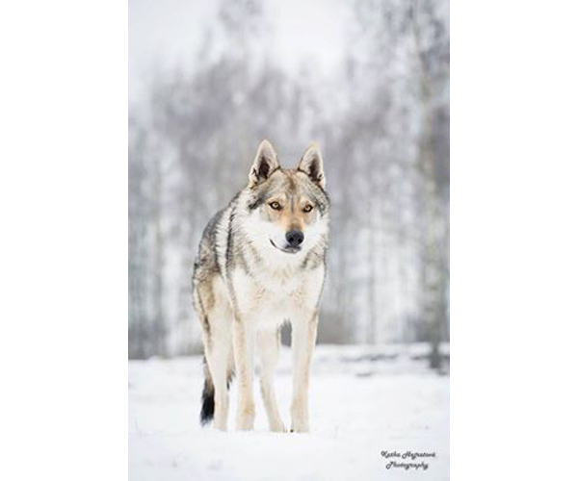

23.川东犬(重庆犬)Chinese Chongqing Dog

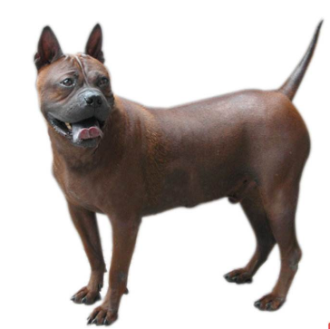
24. 大丹犬Great Dane
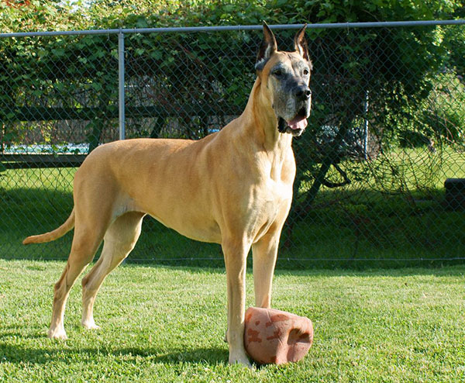
25.佛兰德斯牧牛犬Flanders Cattle Dog
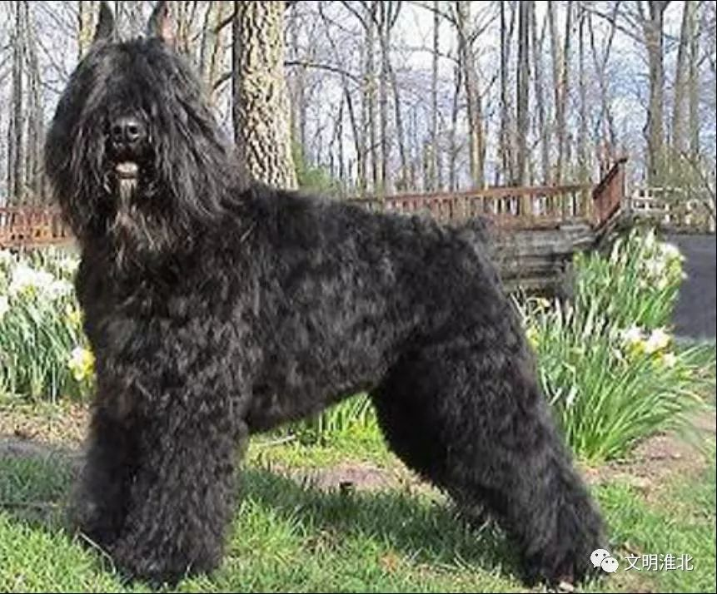

26.牛头梗Bull Terrier
27.纽芬兰犬New Found Land
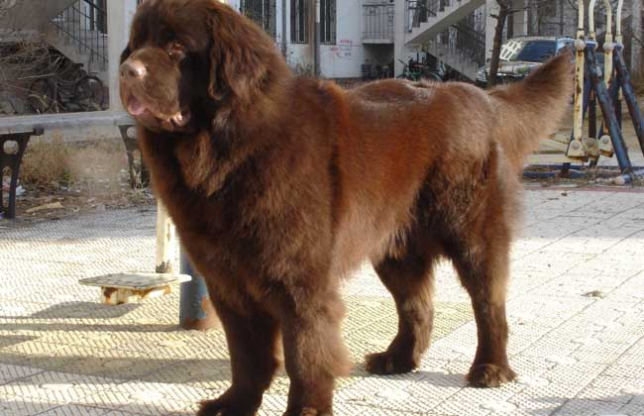

- 爱尔兰猎狼犬Irish Wolfhound
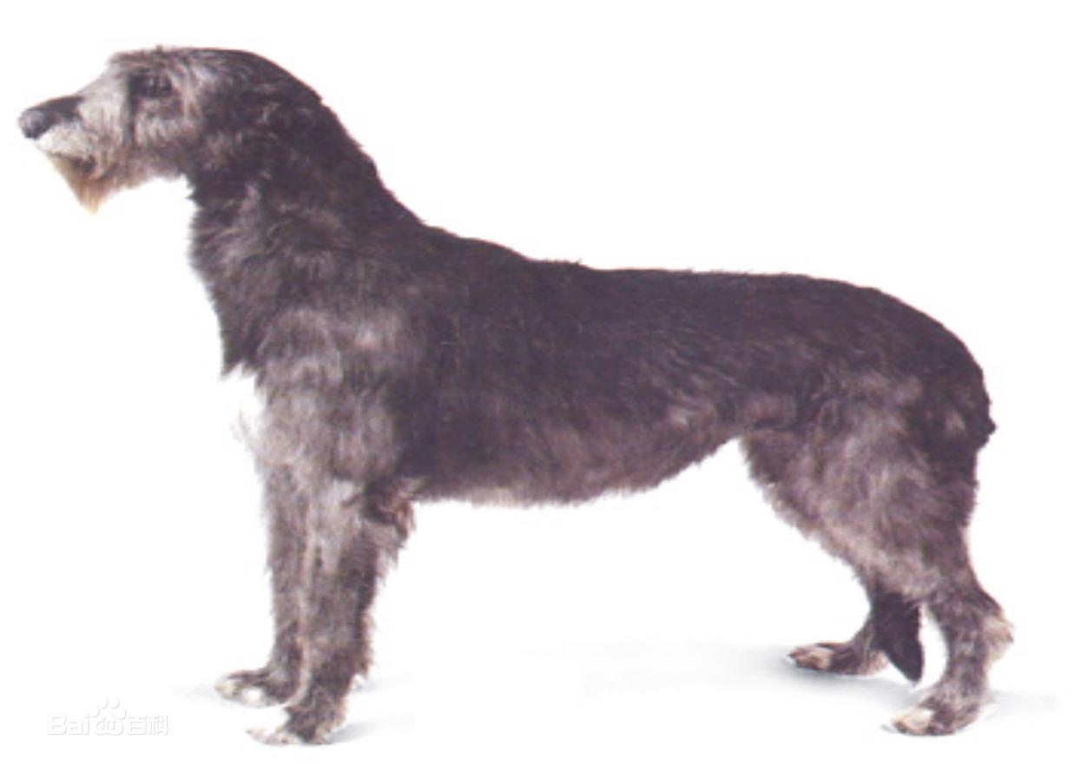

29.阿富汗猎犬Afghan Hound
30.威玛猎犬Weimaraner
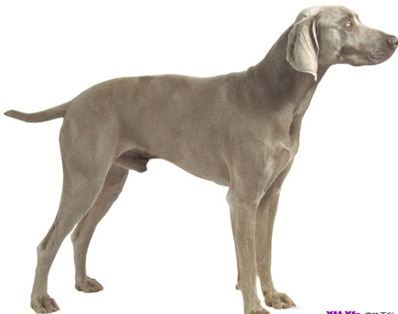
31.大白熊犬Great Pyreness

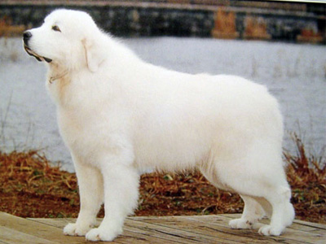
32.安纳托利亚牧羊犬 Anatolian Shepherd

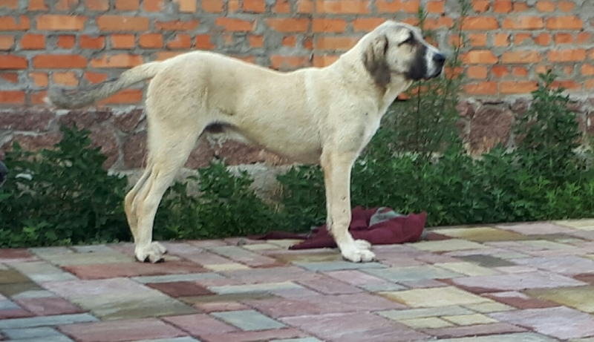

33.昆明犬 Kunming Dog

